ChristKindlFest 2013
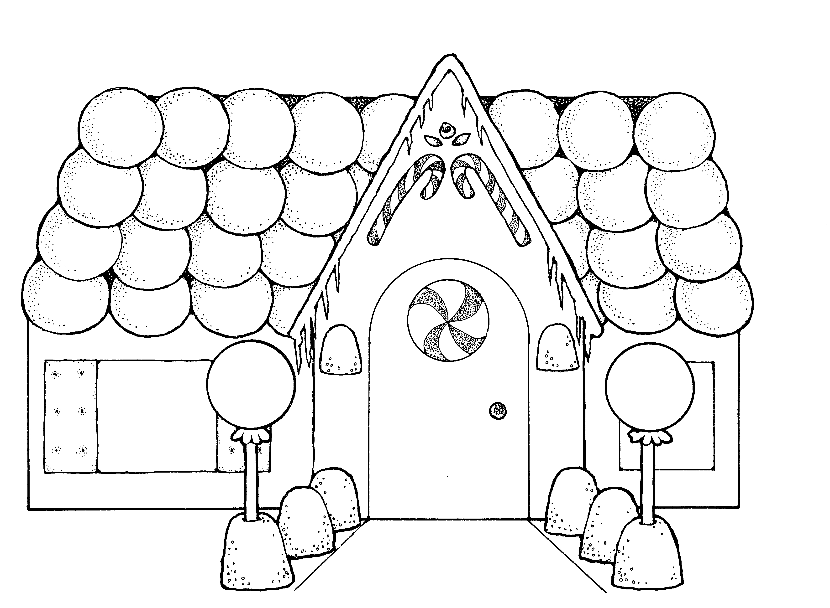
Gingerbread House Competition
Details:

All Entry Forms are due by Friday, November 1, 2013.

CATEGORIES:
Youth, Adult & Family
Individuals and Teams will compete in the following groupings:
Youth: Grades 1-4; 5-8; 9-12; Adult(s) 18 years and older; Family with 80% of project done by Youth(s).
Due to space limitations, Youth, Adult & Family entries will be limited to the first 10 Applications
received In each category. Those accepted will be notified by phone on Monday, November 4 , 2013.
Culinary Student
Culinary students from local colleges, community colleges and culinary institutions have been invited to participate. Each Institution is invited to submit up to three entries.

GINGERBREAD HOUSE
- must be made completely of edible products. – gingerbread, sugar, icing, marzipan, candies, etc. All candies must be unwrapped.
- no artificial display materials accepted [Styrofoam or interior lighting] in construction of the house.
- Youth, Adult & Family: not to exceed 1 foot High, 1 foot Wide, 1 foot Deep.
Culinary Student: not to exceed 2 feet High, 2 feet Wide, 2 feet Deep.
The above dimensions include the board or tray the Gingerbread House sits on (plywood preferred).
- ChristKindlFest has the right to refuse any Gingerbread House entries deemed inappropriate for display.
- all entrants give ChristKindlFest permission to use pictures of their entry for publicity purposes.
- Youth Adult & Family: deliver your Gingerbread House to a designated assigned merchant on
Friday, November 15, 2013 between 10am and 5pm.
Culinary Student: deliver your Gingerbread House to The Ice House, 200 Applebee St., Barrington
Phone: 847.381-6661 on Friday, November 15, 2013 between 10 am and 6pm.
- please attach 3in. X 5in. card with name, telephone number and entry category to your entry.

JUDGING THE WINNERS
Winners from all Gingerbread House categories will be chosen by ChristKindlFest attendees. Packets of 10 raffle tickets will be sold at the Fest. Raffle ticket holders will vote by depositing raffle tickets in the drop box next to each Gingerbread House. The three Gingerbread Houses in each category that receive the most raffle tickets by 3:00pm December 8 will be declared the winners at the Awards Ceremony.
Youth, Adults & Family winners will be awarded 1st, 2nd & 3rd Place Ribbons in each category.
Culinary Student winners will be awarded 1st = $750; 2nd = $500; 3rd = $250 to encourage their continued culinary education.

WINNING A GINGERBREAD HOUSE
One raffle ticket will be drawn from the drop box of each of the Culinary Student Gingerbread Houses. The ChristKindlFest attendees whose raffle ticket is drawn will win that Gingerbread House.
All other non-culinary Gingerbread Houses may be picked up by the Owner(s) form merchant locations on Friday, December20 . Any Gingerbread Houses not picked up by 6pm December 20^{h} become the sole property of the ChristkindlFest

ChristKindlFest 2013
Gingerbread House Competition
Entry Form:

Should you have any questions or concerns, please contact:
Jim Otis
ChristKindlFest 2013
Special Events Coordinator
Tele: 815.459.9204. Email :ejotis162@foxvalley.net

Gingerbread House Entry Form may be
- filled out online: go to ChristKindlFest.com and click on “Events”
- emailed as an attachment to ejotis162@foxvalley.net
- mailed to: Jim Otis, 6206 Haligus Road, Woodstock IL 60098.

PLEASE PRINT

___________________________________ ___________________ ______________________________ Name Telephone eMail

__________________________________________________________________________________________Address City State Zip

Youth:
Grades 1 – 4 _______ Grades 5 - 8 _______ Grades 9 - 12____

Adult
Adult (18+) _______ Culinary student _______
Family
Family project______ with 80% of project done by Youth(s)

*Please include a 5 X 7 photo of your House at delivery time.{ For voting procedures.}

--------------------------------------------------------------- -------------------------------- /// ------------------------------Signature Date Date Received

